1)Write a VB Program to design a simple calculator to perform addition, subtraction, multiplication and division(Use functions for the calculations).

Dim a As Double, b As Double

Dim op As String

Private Sub Command1_Click(Index As Integer)

Text1.Text = Text1.Text + Command1(Index).Caption

End Sub

Private Sub Command2_Click(Index As Integer)

A = Val(Text1.Text)

Text1.Text = ""

If Command2(Index).Caption = "+" Then

op = "+"

ElseIf Command2(Index).Caption = "-" Then

op = "-"

ElseIf Command2(Index).Caption = "*" Then

op = "*"

ElseIf Command2(Index).Caption = "/" Then

op = "/"

End If

End Sub

Private Sub Command3_Click()

b = Val(Text1.Text)

If op = "+" Then

Text1.Text = a + b

ElseIf op = "-" Then

Text1.Text = a - b

ElseIf op = "*" Then

Text1.Text = a * b

ElseIf op = "/" Then

Text1.Text = a / b

End If

End Sub

Private Sub Command4_Click()

Text1.Text = ""

End Sub

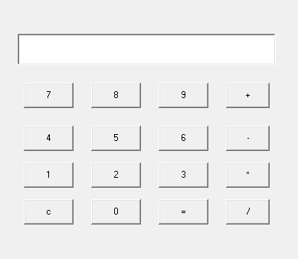

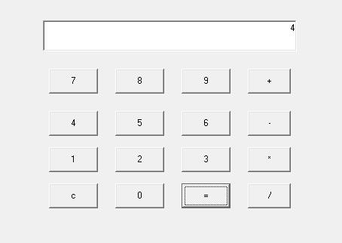

2)Design a User Interface (UI) to accept the student details such as name, department and total marks. Validate the input data and calculate the percentage and division.

STUDENT MARKS

Private Sub Command1_Click()

Dim a As Integer

Text6.Text = Val(Text3.Text) + Val(Text4.Text) + Val(Text5.Text)

Text7.Text = Val(Text6.Text) / 3

a = Val(Text7.Text)

If a > 75 Then

Text8.Text = "Distinction"

ElseIf a > 60 Then

Text8.Text = "First Class"

ElseIf a > 50 Then

Text8.Text = "Second class"

ElseIf a > 40 Then

Text8.Text = "Pass class"

Else

Text8.Text = "Fail"

End If

If Val(Text3.Text) < 35 Then

Text8.Text = "Fail"

End If

If Val(Text4.Text) < 35 Then

Text8.Text = "Fail"

End If

If Val(Text5.Text) < 35 Then

Text8.Text = "Fail"

End If

End Sub

Private Sub Text3_KeyPress(KeyAscii As Integer)

If KeyAscii < 48 Or KeyAscii > 57 Then

KeyAscii = 0

MsgBox "Enter number only"

End If

End Sub

Private Sub Text4_KeyPress(KeyAscii As Integer)

If KeyAscii < 48 Or KeyAscii > 57 Then

KeyAscii = 0

MsgBox "Enter number only"

End If

End Sub

Private Sub Text5_KeyPress(KeyAscii As Integer)

If KeyAscii < 48 Or KeyAscii > 57 Then

KeyAscii = 0

MsgBox "Enter number only"

End If

End Sub

Private Sub Command2_Click()

End

End Sub

